Stable regimes and toruses of one class of impulsive systems

Ivanovsky Leonid

[leon19unknown@gmail.com](mailto:leon19unknown@gmail.com)

Scientific supervisor: Prof. Dr. Glyzin S.D., Faculty of Compuer Science, P.G. Demidov Yaroslavl State University

Let us consider a chain of 3 connected, singularly perturbed oscillators with a delay:

${\dot{u}}_{j}=d\left( {a_{1}u}_{j-1}-{a_{2}u}_{j}+u_{j+1}\right)+λ\left[-1+αf\left(u_{j}\left(t-1\right)\right)-βg\left(u_{j}\right)\right]u_{j}, j=\overline{1,3},$ (1)

where ${ u}_{j}=u_{j}\left(t\right)>0$, parameters $a_{1}, a_{2}∈\{0, 1, 2\}, λ≫1, β>0, α>1+β$ and smooth functions $f\left(u\right), g\left(u\right)∈C^{2}\left(R_{+}\right)$ have entry conditions: $0<βg\left(u\right)<α$, $f\left(0\right)=g\left(0\right)=1$ and $f\left(u\right),g\left(u\right),uf^{'}\left(u\right),ug^{'}\left(u\right)=O(1/u)$, $u→+∞$. There are researched 3 types of system (1) for different values of $a_{1}, a_{2}$ and conditions on $u_{0}$, $u_{4}$: a) $a_{1}=1, a_{2}=2$, $u_{0}=u_{1}, u_{3}=u_{4}$; b) $a_{1}=1, a_{2}=2,$ $u_{0}=u_{3}, u_{1}=u_{4}$; c) $a_{1}=0, a_{2}=1, u_{1}=u_{4}$. In articles [1-3] there were proved, when $λ$ is sufficiently great, system (1) can be transformed to the two-dimensional system of differential equations without small parameters, but with impulsive influences

$\left\{\begin{aligned}\dot{y_{1}}=d(e^{y_{2}}+{a_{1}e}^{-y_{1}}-e^{y_{1}}-{a_{1}e}^{-y_{0}}) \\ \dot{{ y}_{2}}=d(e^{y_{3}}+{a_{1}e}^{-y_{1}}-e^{y_{1}}-{a_{1}e}^{-y_{0}})\end{aligned}\right.$ (2)

$y_{j}\left(+0\right)=\frac{α-1}{α-β-1}y_{j}\left(-0\right),$ $y_{j}\left(1+0\right)=y_{j}\left(1-0\right)-\frac{α}{α-1}y_{j}\left(+0\right),$

$y_{j}\left(α+0\right)=\left(1+β\right)y_{j}\left(α-0\right),$

$y_{j}\left(α+1+0\right)=y_{j}\left(α+1-0\right)-\frac{α}{1+β}y_{j}\left(α+0\right)$, $j=\overline{1,2}$

where values of $y_{0}$ and $y_{3}$ depend on entry conditions on $u_{0}$ and $u_{4}$: a) $u_{0}=u_{1}, u_{3}=u_{4}$: $y_{0}=y_{3}=0$ b) $u_{0}=u_{3}, u_{1}=u_{4}:$ $y_{0}=y_{3}=-(y_{1}+y_{2})$ c) $u_{1}=u_{4}:$ $y_{3}=-(y_{1}+y_{2})$. Functions $y_{1}$ and $y_{2}$ are connected with initial variables by means of approximate equalities $y_{1}≈\ln{u_{2}}-\ln{u_{1}}, y_{2}≈\ln{u_{3}}-\ln{u_{2}}$ and describe phase shifts of components in system (1).

Let us consider solutions of system (2) $y_{1}\left(t, z_{1}, z_{2}\right), y_{2}\left(t, z_{1}, z_{2}\right)$ with entry conditions $y_{1}\left(-0, z_{1}, z_{2}\right)=z_{1}, y_{2}\left(-0 z_{1}, z_{2}\right)=z_{2}$. For map

$Ф\left(z\right): \left({z_{1} \atop z_{2}}\right)→\left({y_{1}\left(T_{0}, z_{1}, z_{2}\right) \atop y_{2}\left(T_{0} z_{1}, z_{2}\right)}\right),$ (3)

there was proved that exponentially stable points of map (3) are satisfied the orbitally, asymptotically stable cycles of system (1) and (2). $T_{0}=α+1+(β+1)/(α-β-1)$ is the first approximation of stable cycle of single oscillator of system (1).

An asymptotic analysis shows, that this map has at least 4 stable points, when parameter $d$ is sufficiently small. Moreover zero balance state is stable for any values of $d$. It is satisfied a homogeneous synchronous cycle of system (2). The task of research is to find values of parameters $α$ and $β$, when map (3) has maximal amount of stable points. Also there are researched bifurcations in a phase space of map (3). The research of map was implemented by means of special software, which used parallel independent streams on CPU. Given numerical results are shown as a phase portrait of map (3). There are researched questions of existence and stability of periodic solutions depending on different values of initial parameters. Also the special attention was paid to the number of coexisting stable regimes of map (3).

This work was supported by the Russian Science Foundation (project nos. №14-21-00158).

In the case $a_{1}=1, a_{2}=2, u_{0}=u_{1}, u_{3}=u_{4}$ on coordinate plane of parameters $(α, β)$ there are regions $A_{1}, A_{2}, A_{3}$ and curves $l_{0}, …, l_{4}$. They are shown on fig.1.

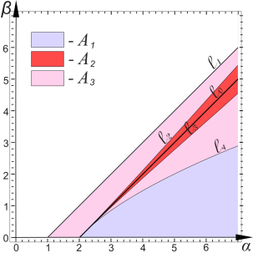

Fig. 1. Regions with the same bifurcations

The most important element for building of regions is line $l_{0}=\{\left(α,β\right): β=α-2\}$. Curves $l_{2}$ and $l_{3}$ are symmetric relative to line $l_{0}$ and touch each other in point (2, 0). These curves are borders of region $A_{2}=\{\left(α,β\right): β<l_{2}, β>l_{3}\}$. Also in point (2, 0) curve $l_{4}$ traces to line $l_{0}$. It permits to determine region $A_{1}=\{\left(α,β\right): β<l_{4}, β>0\}$. Doubly connected region $A_{3}=\{\left(α,β\right): β<l_{3}, β>l_{4}, β<l_{1}, β>l_{2}\}$, where line $l_{1}=\{\left(α,β\right): β=α-1\}$ describes one of conditions for $α$ and $β$ in system (1).

The borders of regions depend on maximal amount of stable points, which are detected there for map (3). For values of parameters $α$ and $β$ from region $A_{1}$ it is possible to exist 5 stable points (fig. 2a). In regions $A_{2}$ and $A_{3}$ it is possible to exist 7 (fig. 2b) and 6 stable points (fig. 2c), respectively.

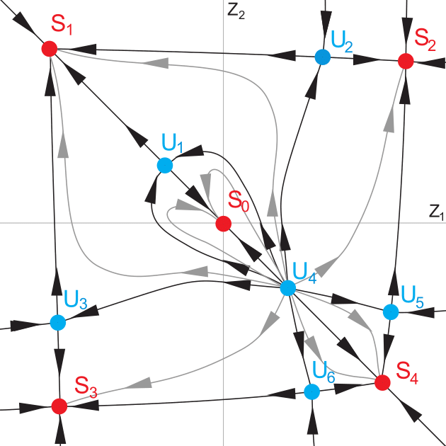 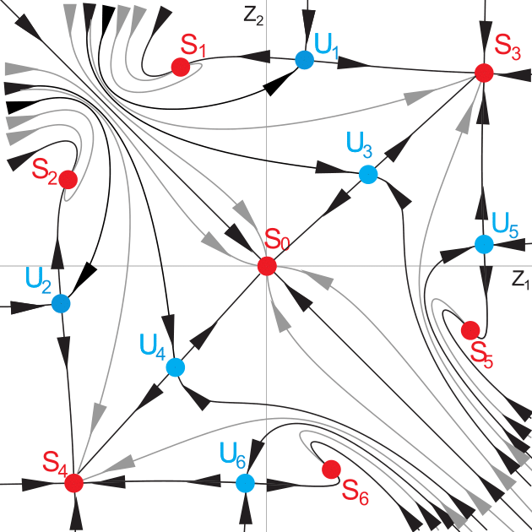 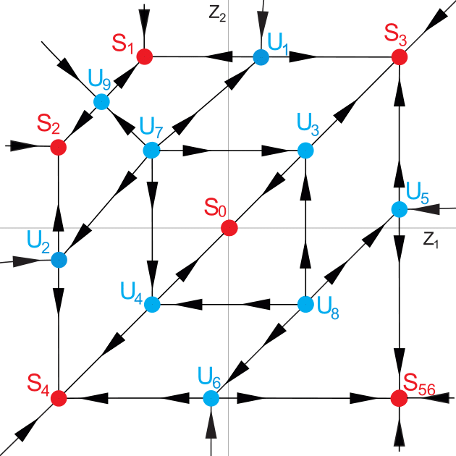

a) $\left(α,β\right)∈A_{1}$ b) $\left(α,β\right)∈A_{2}$ c) $\left(α,β\right)∈A_{3}$

Fig. 2. Phase portraits of map

In article [4] there are examples of different bifurcations for certain values of initial parameters.

In the case $a_{1}=1, a_{2}=2, u_{0}=u_{3}, u_{1}=u_{4}$ on coordinate plane of parameters $(α, β)$ there are regions $A_{1}, A_{2}, A_{3}$ and curves $l_{0}, …, l_{3}$. They are shown on fig.3.

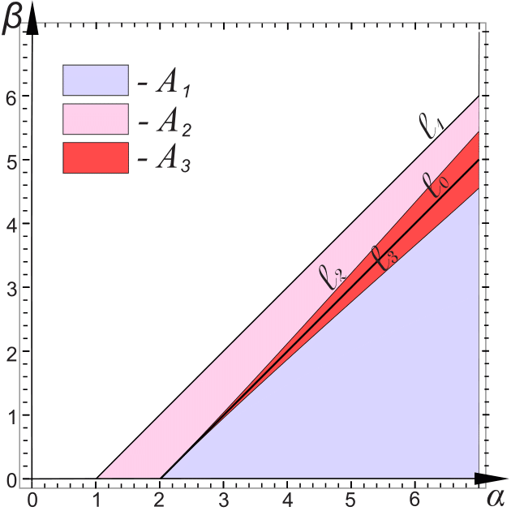

Fig. 3. Regions with the same bifurcations

For values of parameters $α$ and $β$ from regions $A_{1}=\{\left(α,β\right): β>0, β<l_{3}\}$ (fig. 4a) and $A_{2}=\{\left(α,β\right): β>l_{2}, β<l_{1}\}$ (fig. 4b) it is possible to exist 7 stable points for map (3). The difference between these cases is the types of unstable points $U_{1}, …, U_{6}$. In region $A_{3}=\{\left(α,β\right): β>l_{3}, β<l_{2}\}$ there is an unstable manifold $M_{U}$ around zero balance state $S_{0}$ instead of unstable points $U_{1}, …, U_{6}$ (fig. 4c). Every point of this manifold is an unstable state.

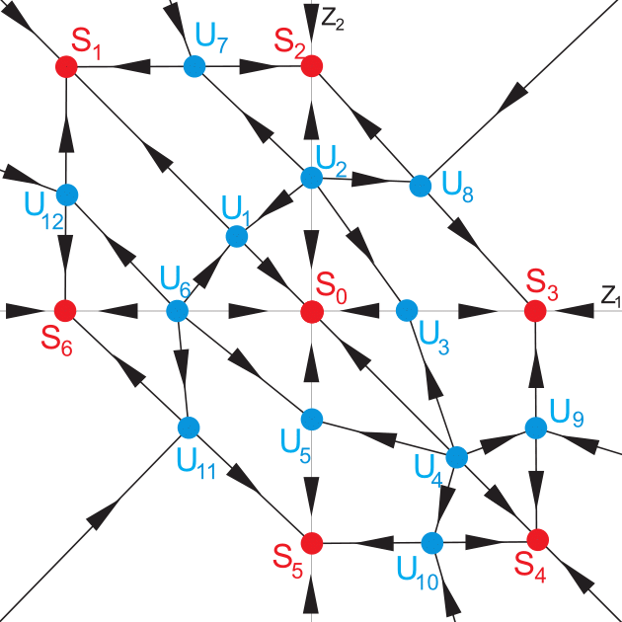 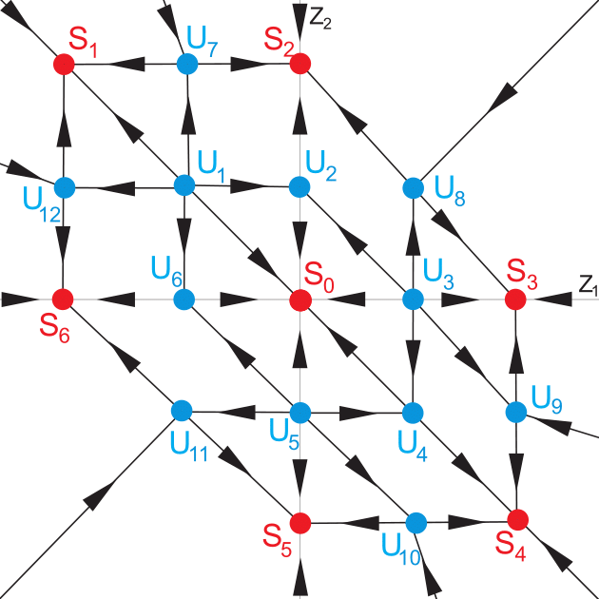 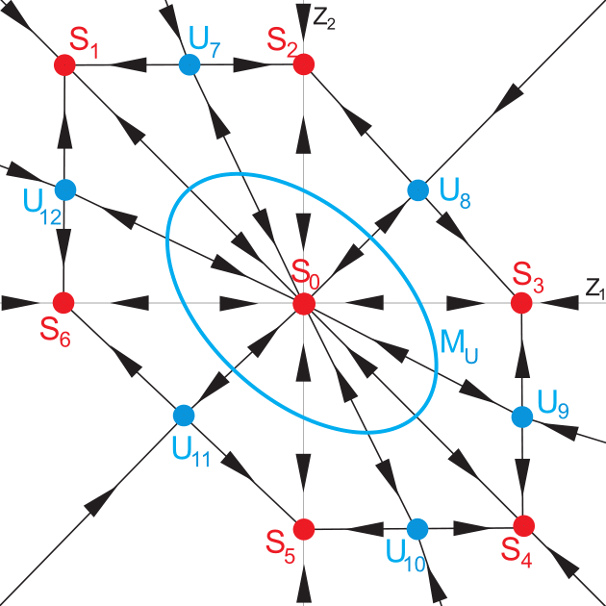

a) $\left(α,β\right)∈A_{1}$ b) $\left(α,β\right)∈A_{2}$ c) $\left(α,β\right)∈A_{3}$

Fig. 4. Phase portraits of map

In article [5] there are examples of different bifurcations for certain values of initial parameters.

In the case $a_{1}=0, a_{2}=1, u_{1}=u_{4}$ on coordinate plane of parameters $(α, β)$ there are regions $A_{1}, A_{2}, A_{3}$ and curves $l_{0}, …, l_{5}$. They are shown on fig.5.

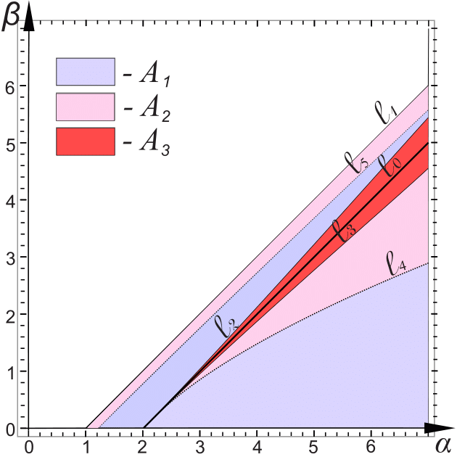

Fig. 5. Regions with the same bifurcations

Line $l_{5}$ comes nearer to curve $l_{2}$, when parameter $α$ increases. Curves $l_{0}, …, l_{5}$ permit to describe regions $A_{1}=\{\left(α,β\right): β>0, β<l_{4},β>l_{2}, β<l_{5} \}$, $A_{2}=\{\left(α,β\right): β>l_{4}, β<l_{3},β>l_{2}, β<l_{5} \}$ and $A_{3}=\{\left(α,β\right): β>l_{3}, β<l_{2} \}$. The borders of regions depend on bifurcations and maximal amount of stable points, which are detected there for map (3) For values of parameters $α$ and $β$ from region $A_{1}$ (fig. 6a) and $A_{2}$ (fig. 6b) it is possible to exist 4 stable points. And in region $A_{3}$ it is possible to exist 6 stable points and unstable manifold $M_{U}$ around zero stable state (fig. 6c).

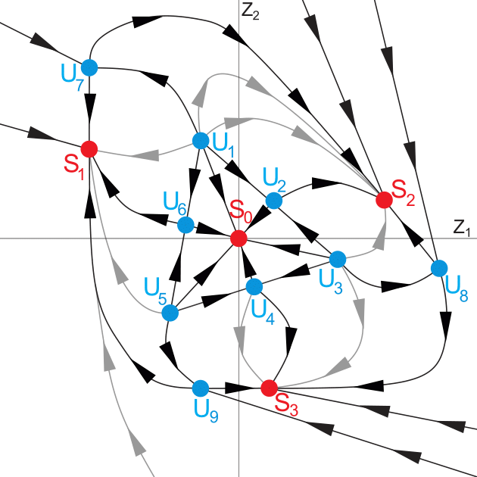 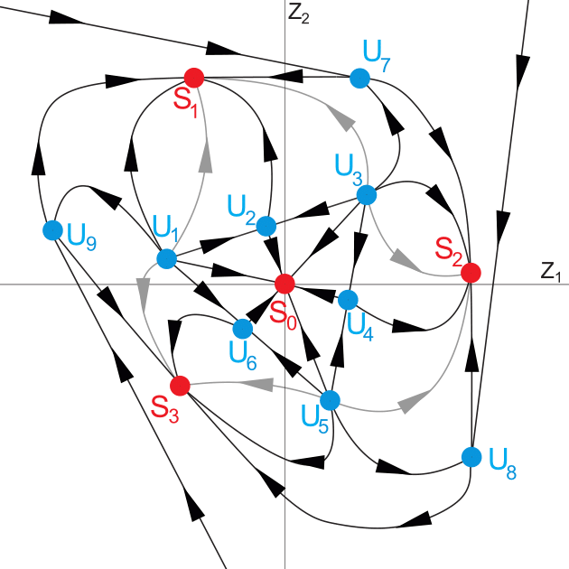 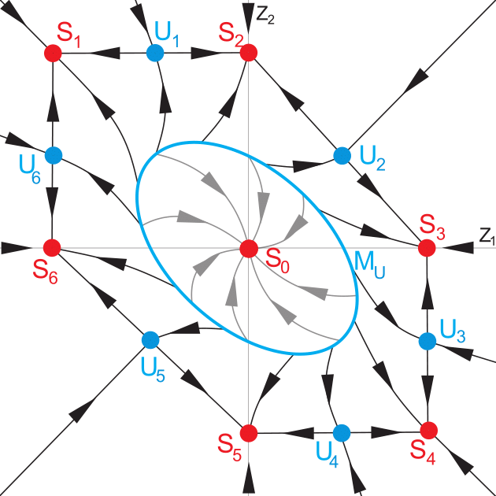

a) $\left(α,β\right)∈A_{1}$ b) $\left(α,β\right)∈A_{2}$ c) $\left(α,β\right)∈A_{3}$

Fig. 6. Phase portraits of map

For every region $A_{1}, A_{2}$ and $A_{3}$, as in articles [4, 5] there were given all possible bifurcations in a phase space of map (3). The difference is the bifurcational value of $d$.

**References**

1. Glyzin S.D., Kolesov A.Yu., Rozov N.Kh. Relaxation self-oscillations in neuron systems. I // Differential Equations. 2011. V. 47, № 7. P. 927 – 941.
2. Glyzin S.D., Kolesov A.Yu., Rozov N.Kh. Relaxation self-oscillations in neuron systems. II // Differential Equations. 2011. V. 47, № 12. P. 1697 – 1713.
3. Glyzin S.D., Kolesov A.Yu., Rozov N.Kh. Relaxation self-oscillations in neuron systems. III // Differential Equations. 2012. V. 48, № 2. P. 159 – 175.
4. Ivanovsky L., Samsonov S. Dynamics of two-dimensional mapping and stable regimes of singulary perturbed neuron system// Computer Technologies in Sciences. Methods of Simulations on Supercomputers. Part 2. Proceedings. 2015. P. 121 – 132.
5. Ivanovsky L. Dynamic properties of one class of impulse systems // Computer Technologies in Sciences. Methods of Simulations on Supercomputers. Part 3. Proceedings. 2015. P. 126 – 131.